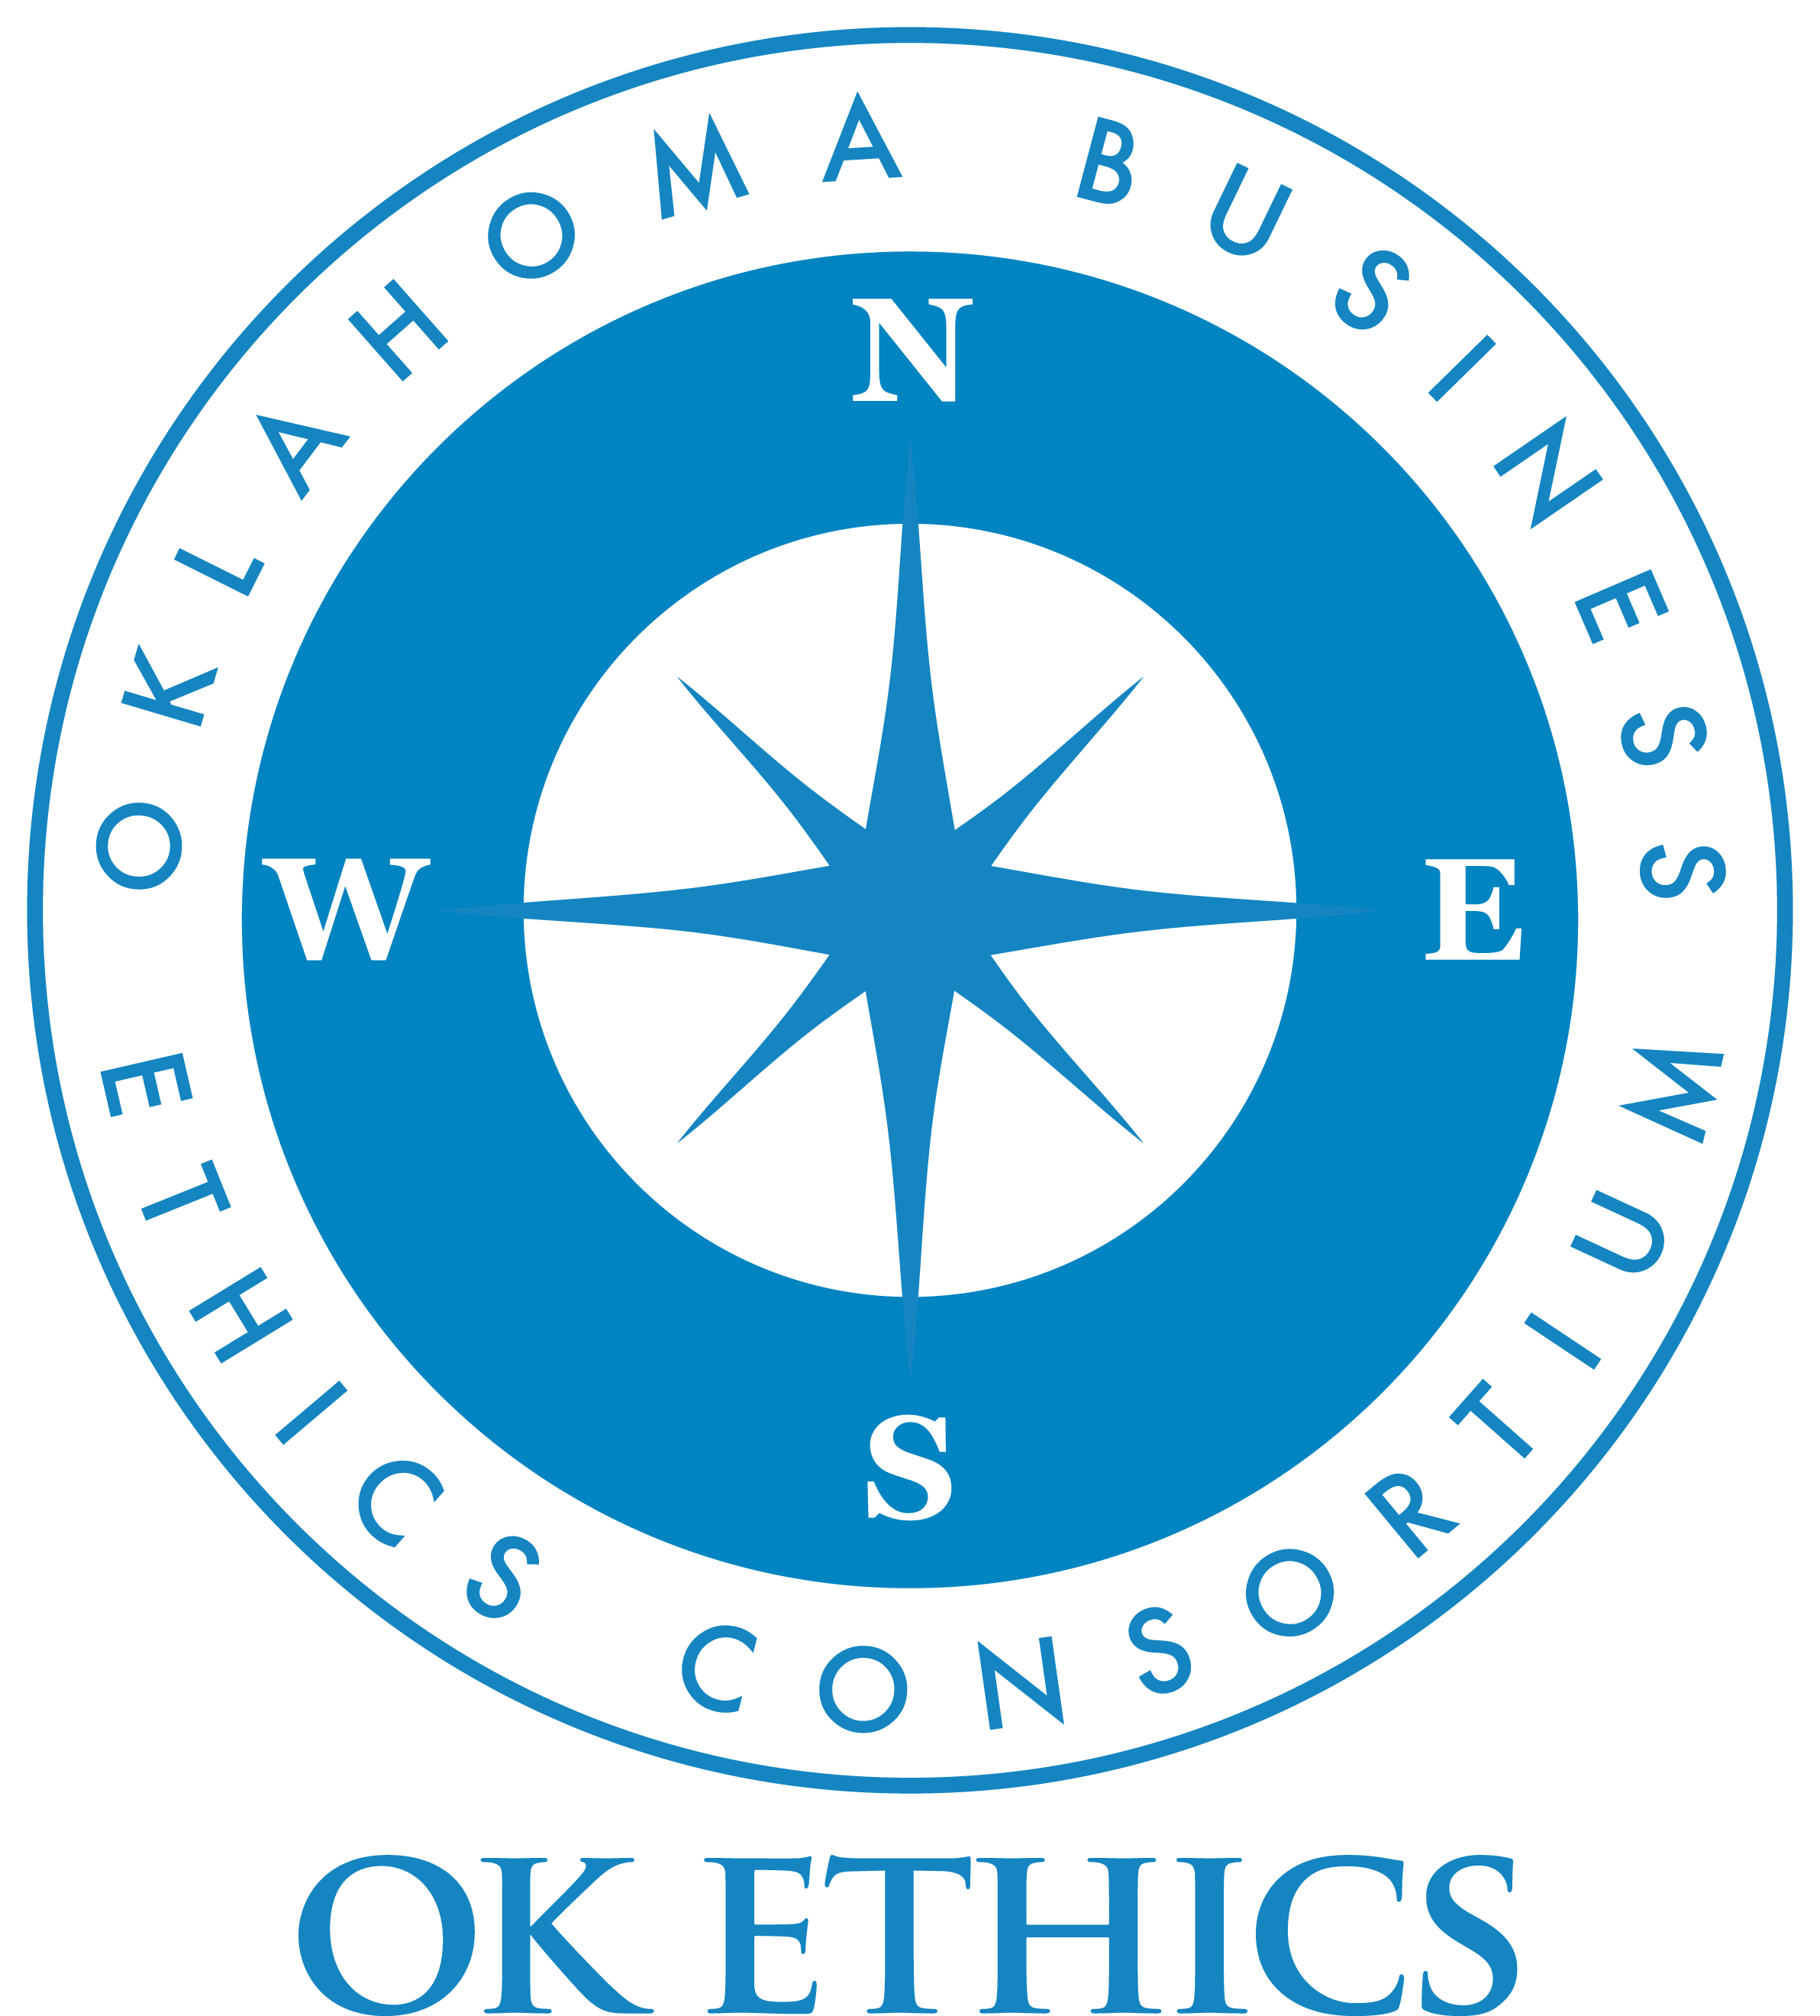

“GENERATIONAL DIFFERENCES IN ETHICAL DECISION-MAKING”
Presentation by:
Dr. Ken Eastman,
Oklahoma State University
and
Dr. Harry Hutson, Devon Energy
January 14, 2009



VISION: To be recognized as a statewide (and national)
forum for promoting business ethics.

General Disclaimer: Members of the Oklahoma Business Ethics Consortium frequently share information concerning various issues and developments that may have legal implications. The discussions, commentary, and handouts at Consortium meetings or presentations to other organizations are for general informational purposes only. They cover only some aspects of the subject topic, and do not constitute a complete legal analysis of the topic or how it might apply to any particular set of facts. Before taking any action based on information presented during a Consortium event, participants are encouraged to consult a qualified attorney.

The observations and comments of presenters at Consortium meetings and networking are the views and opinions of the presenter and do not constitute the opinion or policies of the Consortium or any of its members. Presenters are respectfully requested to avoid profanity, preaching, politics and self-promotion during their lectures.

Recommended for 1 CPE in Ethics for CPA’s
It is the responsibility of participants to demonstrate applicability of each program for demonstration of earned CPE credits, to his/her area of practice. OK Ethics makes no guarantees. Also, attendees must be present to accept CPE certificate at the conclusion of the program. These cannot be emailed.

